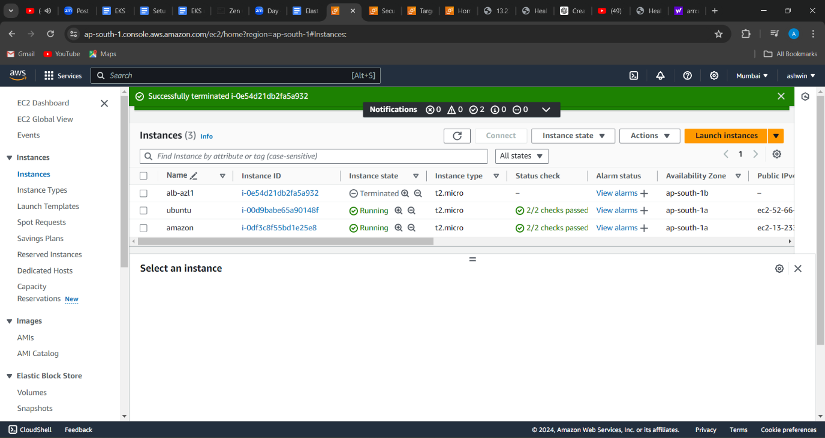

1(launched 2 ec2 machines with web pages)

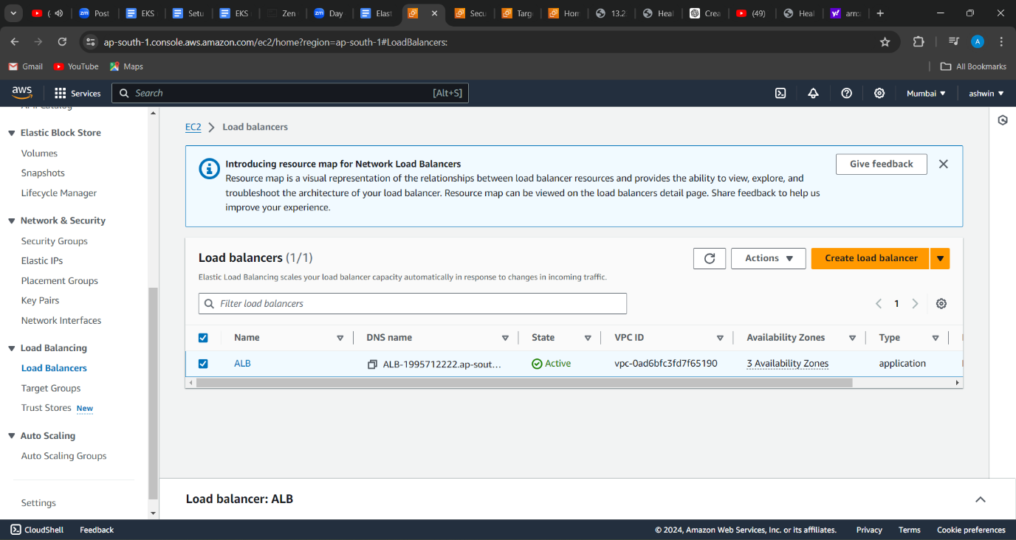

2(created a application load balancer)

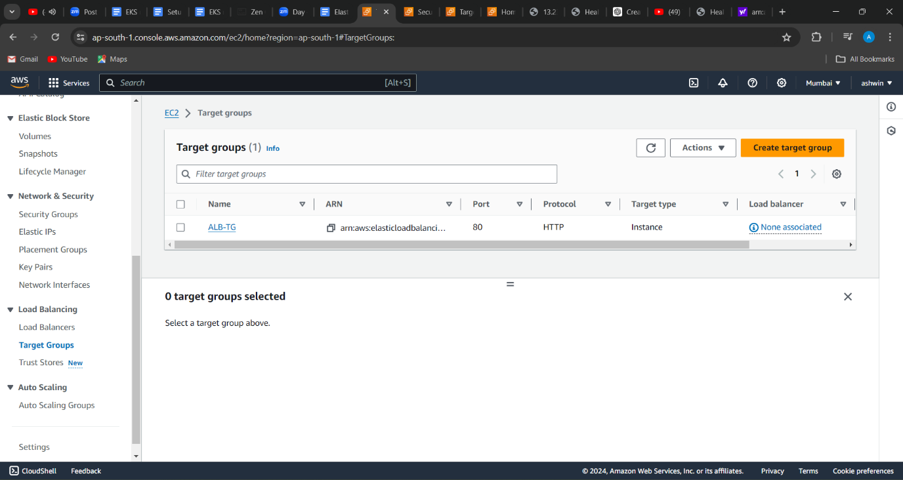

3(created a target group and attached to lb)

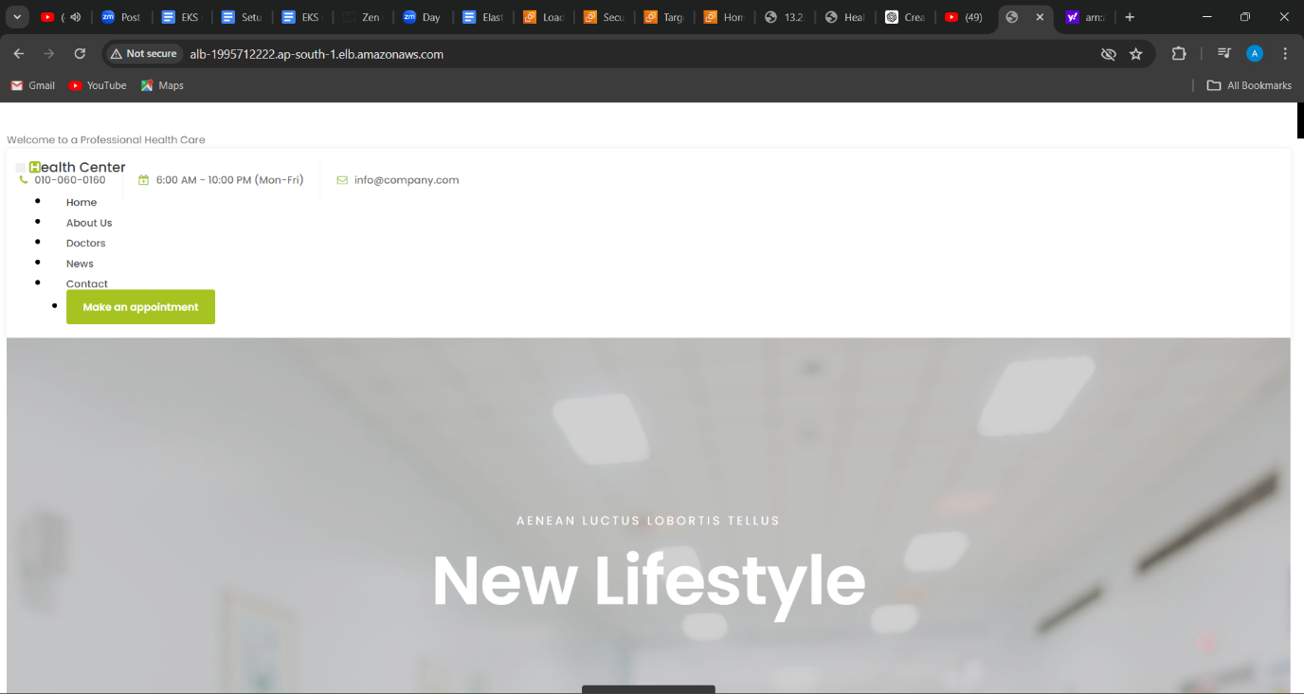

4(output accessed by load balancer IP address 1)

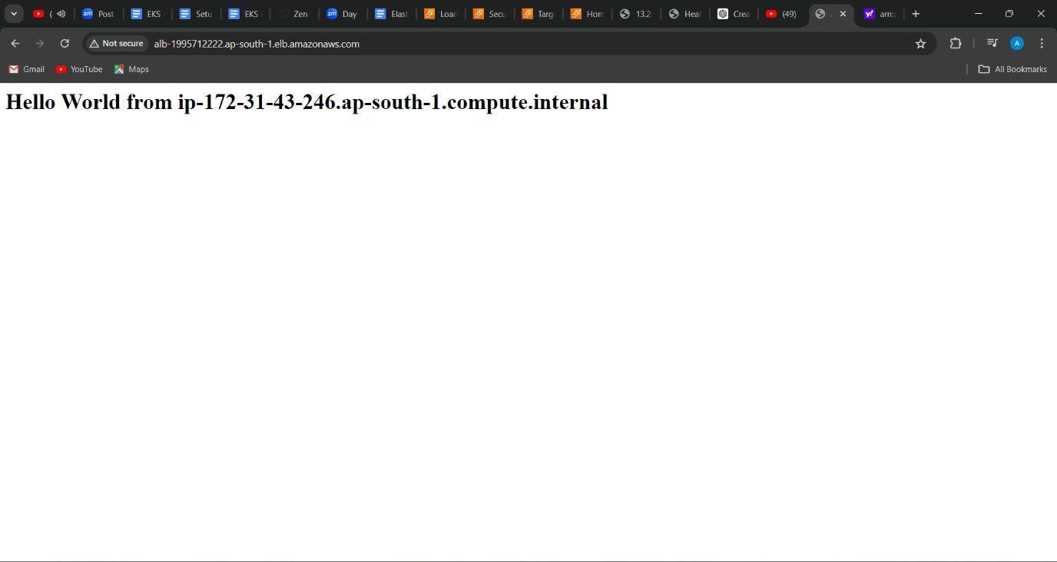

5(output accessed by load balancer IP address 2)